Output Caching in ASP.NET 2.0
http://www.4guysfromrolla.com/articles/121306-1.aspx
By Scott Mitchell

Introduction
One of the most sure-fire ways to improve a web application's performance is to employ caching. Caching takes some expensive operation and stores its results in a quickly accessible location. ASP.NET version 1.0 introduced two flavors of caching:
- Output Caching - caches the entire rendered markup of an ASP.NET web page or User Control for a specified duration.
- Data Caching - a programmatically-accessible, in-memory data cache for storing objects in the web server's memory.
For a more in-depth discussion on ASP.NET 1.x's caching capabilities, refer to Scott McFarland's Caching with ASP.NET and Steve Smith's ASP.NET Caching: Techniques and Best Practices articles.
In ASP.NET 2.0, the caching system has been extended to include SQL cache dependencies, cache profiles, and post-cache substitution for output cached pages. The Caching for Performance section of the ASP.NET 2.0 QuickStarts provides a good overview of ASP.NET 2.0's caching options. This article explores output caching in ASP.NET 2.0, starting with an overview of output caching and followed by a detailed look at creating pages that include both cached and non-cached markup using fragment caching and post-cache substitution techniques. Read on to learn more!

An Overview of Output Caching
Output caching improves the performance of an ASP.NET application by caching the rendered markup of an ASP.NET web page and serving this content instead of re-rendering the page. For example, imagine that you had an ASP.NET page that displayed the records from a database table named Employees that listed the current employee information. Without caching, each time this page is accessed a connection is made to the database, the table queried, and the results returned to the requesting client. But how often does the employee information change? Probably not more than once a day or so, making many of those requests to the database superfluous. With output caching, when this page is first visited the rendered HTML will be cached for a specified duration. During that time period, if a user requests this page, the cached markup will be returned, thereby saving the database access and page rendering costs.
That's output caching in a nutshell! To implement output caching, simply add the <% @OutputCache %> directive to the top of your page like so:
<%@ Page ... %>
<%@ OutputCache Duration="duration" VaryByParam="paramList" %>
duration is the number of seconds for which the rendered markup remains in the cache. paramList is a list of parameters whose values vary the cache. For example, if the page that displays employees displays just those employees in a particular department as determined by a querystring parameter, then we want to vary the cache by this parameter. To be more precise, imagine that our employee page displays a particular department's employees when visited like ShowEmployees.aspx?DepartmentID=departmentID. If the cache is not varied by any parameter then when a user visits ShowEmployees.aspx?DepartmentID=Sales, the employees in the sales department will be returned and that markup will be cached. If within that cache duration a user visits ShowEmployees.aspx?DepartmentID=IT, they will still see the cached sales staff rather than the IT staff.
To fix this, we simply need to instruct the output cache engine to vary its cache by the DepartmentID parameter:
<%@ OutputCache Duration="duration" VaryByParam="DepartmentID" %>

To vary by all parameters, use an asterisk (*); to vary by no parameters, use "None".
Output Caching Subtleties
While output caching is painfully easy to implement - just add the <%@ OutputCache %> directive - there are some subtleties that are worth noting. As discussed earlier, it's important to properly vary the cache so that the correct cached version is served based on the values of the input parameters. In addition to VaryByParam, there are additional VaryByX options that should be considered. For example, you may want to vary the cache by the browser, since antequated browsers are rendered with HTML 3.2 markup. Also if you have a multi-lingual site, you'll want to vary the output by whatever parameters you're using to determine the language to display. Refer to ASP.NET Caching: Techniques and Best Practices for details on varying the cache by HTTP headers or custom values.

Looking Into the Guts of Output Caching
Output caching is implemented in ASP.NET as an HTTP Module, in particular the OutputCacheModule class in the System.Web.Caching namespace. An HTTP Module listens to the events that fire during the lifecycle of a request and can execute code when a particular events fire. The OutputCacheModule HTTP Module subscribes to the ResolveRequestCache and UpdateRequestCache events. In the ResolveRequestCache event, the module determines if the file being requested participates in output caching and, if so, there's a cache version to send back. If there's not a cached version, the page is rendered as normal. On the way out when the UpdateRequestCache event fires, the module will cache the rendered output (if the page is setup to support output caching). The following sequence diagram oversimplifies the tasks performed by the OutputCacheModule module, but highlights the overall workflow.
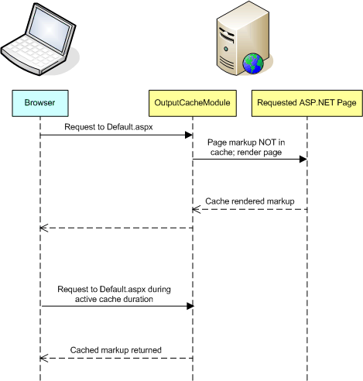
If you want a page's output cache to expire before the specified duration is reached, there are two options. You can programmatically remove the output cached content for a particular page by calling the Response.RemoveOutputCacheItem(path) method, where path is the virtual absolute path to the page. You can also associate external dependencies with the output cache, as discussed in Caching Page Output with Cache Key Dependencies. This includes the ability to tie a SQL Cache Dependencies to the output cache for a page; see the SQL Cache Invalidation section of the ASP.NET 2.0 QuickStarts for more information.

Output Caching Only Part of a Page
By default, output caching caches the entire rendered markup of a page. Oftentimes, we want to keep certain portions of the page dynamic, though. We may want to cache the expensive, non-changing items - displays of data, for instance - but keep advertisements, user-specific data, or other oft-changing information "live". In ASP.NET 1.x this could only be done via fragment caching, which allows you to say, "Keep this page dynamic except for these portions." ASP.NET 2.0 supports fragment caching, but also introduces a post-cache substitution model which allows you to say the opposite: "Keep this page cached except for these dynamic portions." Let's look at fragment caching first and then turn our attention to post-cache substitutions.
Fragment caching works by creating a page without output caching that uses a User Control that does use output caching. The download at the end of this article includes a simple example - there's a User Control named CachedUserControl.ascx that displays the records from a database table along with the date/time at which the data was retrieved. This User Control contains an <% @OutputCache %> directive:
<%@ Control ... %>
<%@ OutputCache Duration="15" VaryByParam="None" %>
... markup that displays records from a database table ...
The page that contains this User Control does not have an <% @OutputCache %> directive. The net result is that the page is re-rendered every time it's visited, but the User Control is only re-renderd (and therefore only hits the database) at most once every 15 seconds.
The following screenshot shows the page when it is first visited. Note that the date/time for the page and the User Control are the same. Revisiting the page a few seconds later, however, shows that the User Control is being cached - the page's date/time is up to the second, but the User Control time is from when it was first visited.
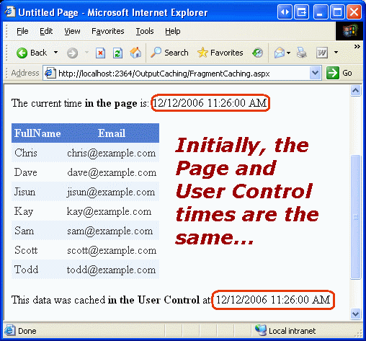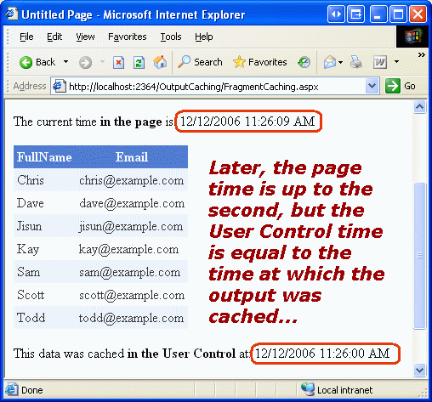
Check out the download available at the end of this article for the page and User Control used in this sample. Also, see How To Perform Fragment Caching in ASP.NET by Using Visual C# .NET for a step-by-step look at a fragment caching demo.

Making Cached Portions of a Page Dynamic Through Post-Cache Substitutions
ASP.NET 2.0 adds another technique to mix cached and dynamic content - post-cache substitutions. As the name implies, this approach takes a page that uses output caching and allows you to make "live" substitutions in the cached content. There are two ways that post-cache substitutions can be applied:
- Declaratively - specify the dynamic portion(s) of a page using Substitution controls. You need to create a method that will be invoked by these controls in order to get their rendered markup.
- Programmatically - the Response.WriteSubstitution(callback) method programmatically injects a response substitution block. The callback parameter is a delegate to a method that will be invoked to get the markup to emit.
To use the declarative case, simply add a Substitution control in your output cached page wherever you want to inject dynamic data.
<%@ Page ... %>
<%@ OutputCache Duration="duration" VaryByParam="paramList" %>
...

<asp:Substitution ID="id" runat="server" MethodName="method" />
...
The MethodName(string) property specifies a static method in the page's code-behind class that must accept an HttpContext object and return the string to emit. Imagine that we had a page that included cached data, but we wanted to include a dynamic message (an advertisement, perhaps). We could add a Substitution control to the page where we wanted the message to appear:
<asp:Substitution ID="DynamicMessage" runat="server" MethodName="GetMessage" />
Here we specified the MethodName as GetMessage. Therefore, we need to create a static method in the page's code-behind class named GetMessage that returns a string:
'VB
Private Shared Function GetMessage(ByVal context As HttpContext) As String
Return "This ad brought to you by the time " & DateTime.Now.ToString()
End Function
// C#
private static string GetMessage(HttpContext context)
{
return "This ad brought to you by the time " + DateTime.Now.ToString();
}
When this page is visited, its content will be cached, as usual. On subsequent visits, though, when the page is still cached, the OutputCacheModule will invoke the GetMessage method and place its output in the appropriate sections of the page.

Conclusion
ASP.NET's output caching feature allows for a page or User Control's entire HTML output to be cached, thereby helping to boost the application's overall performance. The output caching logic is handled by an HTTP handler, OutputCacheModule. Oftentimes, a page needs to have some portions be cached, while leaving others dynamic. ASP.NET 2.0 provides two mechanisms to accomplish this - fragment caching and post-cache substitutions. With fragment caching, the page is left as a normal, dynamic page without output caching. Those regions of the page that should be cached, however, need to be implemented as User Controls that are configured to use output caching. The other avenue is to use post-cache substitution, where the page is configured to use output caching. Substitution controls can be added to the page to indicate areas where content should be dynamically generated on each page visit regardless of whether the page is cached. Post-cache substitutions are new to ASP.NET 2.0.
Update (June 16, 2010): Starting with ASP.NET 4 you can extend output caching using the provider model. Learn more at Extending ASP.NET Output Caching...
Happy Programming!
• By Scott Mitchell

Further Reading:
• Caching for Performance
• ASP.NET Caching: Techniques and Best Practices
• ASP.NET Micro Caching: Benefits of a One-Second Cache
• Implement "Donut Caching" with the ASP.NET 2.0 Output Cache Substitution Feature
• Extending ASP.NET Output Caching

Attachments
• Download the Code Discussed in this Article
Published: Wednesday, June 16, 2010

Extending ASP.NET Output Caching
http://www.4guysfromrolla.com/articles/061610-1.aspx
By Scott Mitchell

Introduction
One of the most sure-fire ways to improve a web application's performance is to employ caching. Caching takes some expensive operation and stores its results in a quickly accessible location. Since it's inception, ASP.NET has offered two flavors of caching:
- Output Caching - caches the entire rendered markup of an ASP.NET page or User Control for a specified duration.
- Data Caching - a API for caching objects. Using the data cache you can write code to add, remove, and retrieve items from the cache.
Until recently, the underlying functionality of these two caching mechanisms was fixed - both cached data in the web server's memory. This has its drawbacks. In some cases, developers may want to save output cache content to disk. When using the data cache you may want to cache items to the cloud or to a distributed caching architecture like memcached. The good news is that with ASP.NET 4 and the .NET Framework 4, the output caching and data caching options are now much more extensible. Both caching features are now based upon the provider model, meaning that you can create your own output cache and data cache providers (or download and use a third-party or open source provider) and plug them into a new or existing ASP.NET 4 application.
This article focuses on extending the output caching feature. We'll walk through how to create a custom output cache provider that caches a page or User Control's rendered output to disk (as opposed to memory) and then see how to plug the provider into an ASP.NET application. A complete working example, available in both VB and C#, is available for download at the end of this article. Read on to learn more!

A Quick Overview of ASP.NET's Output Caching
Output caching has been a feature of ASP.NET since its inception. In a nutshell, output caching allows developers to cache the rendered output of an ASP.NET page or User Control for a specified duration. Output caching can improve the performance of a website by caching the rendered markup of a page on an initial request so that on subsequent requests the page does not need to be re-rendered (as its cached version is returned).
For example, imagine that you had an ASP.NET page that displayed the records from a database table named Employees that listed the current employee information. Without caching, each time this page is accessed a connection is made to the database, the table queried, and the results returned to the requesting client. But how often does the employee information change? Probably not more than once a day or so, making many of those requests to the database superfluous. With output caching, when this page is first visited the rendered HTML will be cached for a specified duration. During that time period, if a user requests this page, the cached markup will be returned, thereby saving the database access and page rendering costs.
To implement output caching, simply add the <% @OutputCache %> directive to the top of your page like so:
<%@ Page ... %>
<%@ OutputCache Duration="duration" VaryByParam="paramList" %>
duration is the number of seconds for which the rendered markup remains in the cache. paramList is a list of parameters whose values vary the cache. For example, if the page that displays employees displays just those employees in a particular department as determined by a querystring parameter, then we want to vary the cache by this parameter.
Output caching can be used to cache the entire contents of a web page, but oftentimes there are specific regions in a page that need to remain dynamic. Perhaps part of the page shows the name of the currently logged on user or is dynamically generated to show randomly selected advertisements. In these cases, it is important that these parts of the page remain dynamic. There are two mechanisms by which dynamic regions can be defined when using output caching:
- Donut caching - allows you to define dynamic regions in an output cached web page, and
- Fragment caching - enables cached regions to be created (via User Controls) within a dynamic page.
By default, output caching stores the rendered markup of ASP.NET pages and User Controls in the web server's memory. As this article shows, with ASP.NET 4 it is possible to create a custom output cache provider that stores the rendered output elsewhere - to disk, to the cloud, to a distributed caching architecture, etc.
For more information on output caching, including a closer look at fragment caching and donut caching, refer to a previous article of mine, Output Caching in ASP.NET.

Creating a Custom Output Cache Provider
Implementing your own logic for ASP.NET's output caching behavior involves creating a custom output cache provider, which is a class that must derive from the OutputCacheProvider class, which is found in the System.Web.Caching namespace. This class defines four abstract methods, which we must implement. These four methods are responsible for adding, updating, retrieving, and removing items from the cache. Moreover, these methods are all passed a key, which is a string that uniquely identifies the item to be added to the cache / retrieved from the cache / removed from the cache. Also, keep in mind that with output caching items are cached for a duration, so when adding or updating items in the cache, an time value is passed in, which specifies the expiry of the cache item in universal time.
- Add - this method is passed a key, the object to add to the cache, and its expiry. However, if there already exists an item in the cache with this key, the Add method must return the data associated with the key and not add the passed-in data.
- Get - this method is passed a key and returns the requested cached data (if it still exists in the cache and hasn't expired).
- Remove - this method is passed a key and is tasked with removing that key (and its data) from the cache.
- Set - this method is passed a key, the object to add or update in the cache, and its expiry.
To see these methods in action, I've created a disk-based custom output cache provider class named DiskOutputCacheProvider, which is available for download at the end of this article. (The code samples we'll see in this article are in C#, but the download includes two projects - one in C# and one in VB.) Each time a request comes into the DiskOutputCacheProvider class to add, remove, or update a cache item, the DiskOutputCacheProvider class needs to track the expiry of the cache item and the name of the file where the cached data is located. This is handled by a property named CacheItems, which is a Dictionary object that associates the cache key supplied by ASP.NET with a DiskOutputCacheItem object. The DiskOutputCacheItem class, which I created, has two properties - FileName and UtcExpiry - that indicate where the cached data is stored on disk and when it expires.
The actual files are stored on disk in the ~/DiskCache folder, although this folder name can be customized when registering the custom output cache provider in Web.config. In addition to storing the cached data to disk, the DiskOutputCacheProvider class also maintains a log file (~/DiskCache/log.txt) that tracks what methods were called and what key and expiry information was supplied. Note that this logging only occurs when the application is in debug mode (that is, when Web.config has <compilation debug="true" />).
Let's examine some of the more interesting methods in the DiskOutputCacheProvider class, starting with the Set method. Recall that the Set method is called to add or update an item in the cache. It is passed a key, the data to cache, and its expiry.
public override void Set(string key, object entry, DateTime utcExpiry)
{
var item = new DiskOutputCacheItem(this.GetSafeFileName(key), utcExpiry);
WriteCacheData(item, entry);
// Add item to CacheItems, if needed, or update the existing key, if it already exists
lock (_lockObject)
{
if (this.CacheItems.ContainsKey(key))
this.CacheItems[key] = item;
else
this.CacheItems.Add(key, item);
}
}
The first thing the Set method does is create a DiskOutputCacheItem that stores the name of the file where the data will be cached and the cache item's expiry. The name of the file where the cached data will be stored is determined by the GetSafeFileName method, which removes any characters from key that are not allowed in file names. Next, a call to the WriteCacheData method is made. The WriteCacheData method (not shown here) uses the BinaryFormatter class to serialize the contents of the data to be cached to a file.
After calling the WriteCacheData method, the Set method completes by adding the new DiskOutputCacheItem to the CacheItems Dictionary if the key is not already in there. If the key already exists in CacheItems then it is overwritten with the new DiskOutputCacheItem object. Note that the code that adds or updates CacheItems is done within a lock statement. This ensures that the code within the lock statement is treated as a critical section, meaning that only one thread can execute the code at a time. The reason this lock statement is needed is because there is only one instance of the DiskOutputCacheProvider class for the entire application. Without the lock consider what would happen if two threads entered this method when attempting to cache the same page's output, which currently does not exist in the cache. Imagine that thread 1 reaches the if statement that calls ContainsKey to see if key is in the Dictionary. This will return false (since we are presuming the item is not yet in the cache) so the thread will next call CacheItems.Add to add item to the Dictionary. But if thread 1's time slice ends and thread 2 comes in, we can run into a problem, as thread 2 will undergo the same test and determine that key is not in the Dictionary. So now we have two threads, each of which is trying to add item to the Dictionary using the same key. The lock statement prevents this scenario from unfolding.
The next method I'd like to look at is the Get method. The Get method is responsible for returning the cached data for the specified key if it exists and has not expired. If requested cache item does not exist (or has expired) then Get should return null.
public override object Get(string key)
{
DiskOutputCacheItem item = null;
CacheItems.TryGetValue(key, out item);
// Was the item found?
if (item == null)
return null;
// Has the item expired?
if (item.UtcExpiry < DateTime.UtcNow)
{
// Item has expired
this.Remove(key);
return null;
}
return GetCacheData(item);
}
The Get method starts by seeing if a DiskOutputCacheItem object exists for the specified key. If not, it returns null. If a DiskOutputCacheItem object exists, its expiry is checked. If the item has expired then it is removed from the cache (by calling the Remove method) and null is returned. If the item exists in the cache and has not expired then its data is returned. The GetCacheData method (not shown here) uses the BinaryFormatter class to read the contents of the file and deserialize it.

Registering Your Custom Output Cache Provider
Now that we've examined the DiskOutputCacheProvider class's most important methods, let's turn our attention to actually using DiskOutputCacheProvider in an ASP.NET application. For starters, we need to register our custom provider in Web.config. This is done via the <caching> section's <outputCache> element:
<?xml version="1.0"?>
<configuration>
<system.web>
<compilation debug="true" targetFramework="4.0"/>
<caching>
<outputCache defaultProvider="DiskOutputCache">
<providers>
<add name="DiskOutputCache" type="DiskOutputCacheProvider"/>
</providers>
</outputCache>
</caching>
</system.web>
</configuration>
Note that I've added a provider named DiskOutputCache of type DiskOutputCacheProvider (the name of our custom output cache provider class). Moreover, I've instructed ASP.NET that my custom provider, DiskOutputCache is the default output cache provider. With this configuration in place, anytime my site uses output caching - either through an output cached ASP.NET page or User Control - the DiskOutputCacheProvider custom provider will be invoked.
The output cache provider can also be specified on a per-request basis by overriding the GetOutputCacheProviderName method in Global.asax. This method returns the provider name that the ASP.NET output caching engine should use. By default, it will return the name based on the provider configuration in Web.config, but by overriding this method in Global.asax you can implement custom logic to determine when to use what provider. For instance, you may want to have your homepage and other very popular pages use ASP.NET's internal output cache provider (named AspNetInternalProvider) to store the rendered output in memory, while having all other pages use the disk-based provider we registered in Web.config (DiskOutputCache). The demo application available for download provides an example that shows just how to do this.

Conclusion
ASP.NET has long offered developers the ability to cache the rendered output of their ASP.NET pages and User Controls. Until ASP.NET 4, the output cache engine had fixed internal behaviors, caching the rendered output in the web server's memory. With ASP.NET 4, the output caching and data caching features have been reworked to use the provider model, thereby allowing the underlying behavior to be customized. This article (and its associated code download) showed how to implement a disk-based output cache engine.
Happy Programming!
• By Scott Mitchell

Attachments:
• Download the code used in this article

Further Readings:
• Output Caching in ASP.NET
• Tip/Trick: Implement "Donut Caching" with the ASP.NET 2.0 Output Cache Substitution Feature
• Extensible Output Caching with ASP.NET 4
• Write your own OutputCacheProvider

